

**UNIVERSITY OF ENGINEERING & MANAGEMENT, KOLKATA**

**DEPARTMENT OF COMPUTER SCIENCE AND ENGINEERING (CSE)**

**SEM/YEAR:** 2nd SEMESTER / 2ND YEAR

**SECTION:** 2D

**SUBJECT NAME**: Numerical Method Labs

**PROJECT :** Write a menu driven program using C to solve differential equation by one of the following methods:

1. Euler’s method

2. Modified Euler’s method

3. Runge-Kutta method(4th order)

**GROUP MEMBERS:**

|  |  |
| --- | --- |
| **name** | **Roll** |
| SAGNIK BHATTACHARYA | 46 |
| SANDIPAN MAJUMDAR | 47 |
| DEBJANI CHOWDHURY | 48 |
| DANISH SAMUI | 49 |
| PRATYAY BASU | 50 |

**Objective:**

Write a menu driven program using C to solve differential equation by one of the following methods:

1. Euler’s method
2. Modified Euler’s method
3. Runge Kutta method(4th order)

**Algorithm:**

Step1: start

Step2: create function f(x,y) which returns -2x(y^2)

Step3: create function eulers()

Set i=0

Print x0 and y0

while(x<=a)

{

y=y+f1(x,y,h);

x=x+h;

printf("%0.3f \t%0.3f \n",x,y);

}

[end while]

[end function]

Step4: create function rk()

SET FLOAT k1,k2,k3,k4,k;

SET INTEGER i;

float n=(a-x)/h;

for(i=0;i<n;i++)

{

k1=h*f2(x,y);

k2=h*f2(x+(h/2),y+(k1/2));

k3=h*f2(x+(h/2),y+(k2/2));

k4=h*f2(x+h,y+k3);

k=(k1+(2*k2)+(2*k3)+k4)/6;

y=y+k;x=x+h;

}

printf("The required value= %.3f\n",y); [end while]

[end function]

Step5: create function meulers()

Initialize float m0;

Initialize float k,t=0;

Initialize float m1,m2,w;

Initialize int i;

printf("The respective values of x and y are...\n");

printf("x \t y \n");

for(i=0;x<=a;i++)

{

w=100;

m0=f3(x,y);

printf("%.3f\t%.3f\n",x,y);

x=x+h;

k=y;

while(w>0.0001)

{

m1=f3(x,k);

m2=(m0+m1)/2;

t=y+(m2*h);

w=k-t;

w=fabs(w);

k=t;

// printf("%.3f\n",t);

}

y=t;

}[End]

Step6:

Main()

float x,y,a,h;

printf("Enter a point (x,y)\n");

Input scanf("%f%f",&x,&y);

printf("Enter the x for which the value of y is to be found\n");

Input scanf("%f",&a);

printf("Enter value of h\n");

Input scanf("%f",&h);

printf("1-->Euler's\n2-->Modified eulers\n3-->Runga kutta\nEnter choice\n");

int c;

Input scanf("%d",&c) float x,y,a,h;

printf("Enter a point (x,y)\n");

Input scanf("%f%f",&x,&y);

printf("Enter the x for which the value of y is to be found\n");

Input scanf("%f",&a);

printf("Enter value of h\n");

Input scanf("%f",&h);

printf("1-->Euler's\n2-->Modified eulers\n3-->Runga kutta\nEnter choice\n");

int c;

Input scanf("%d",&c)

Start switch (c)

{

case 1:

eulers(x,y,a,h);

break;

case 2:

meulers(x,y,a,h);

break;

case 3:

rk(x,y,a,h);

break;

default:

printf("Invalid choice\n");

[End Function]

Step7: choose 1 for eulers method, 2 for modified eulers method, 3 for rk method which calls eulers(),meulers(),rk() respectively.

Step8: stop

**Code:**

#include<stdio.h>

#include<math.h>

float f1(float x,float y,float h)

{

return (h*(x+y));

}

void eulers(float x,float y,float a,float h)

{

while(x<=a)

{

y=y+f1(x,y,h);

x=x+h;

printf("%0.3f \t%0.3f \n",x,y);

}

}

float f2(float x,float y)

{

return ((x*x)+(y*y*x));

}

void rk(float x,float y,float a,float h)

{

float k1,k2,k3,k4,k;

int i;

float n=(a-x)/h;

for(i=0;i<n;i++)

{

k1=h*f2(x,y);

k2=h*f2(x+(h/2),y+(k1/2));

k3=h*f2(x+(h/2),y+(k2/2));

k4=h*f2(x+h,y+k3);

k=(k1+(2*k2)+(2*k3)+k4)/6;

y=y+k;x=x+h;

}

printf("The required value= %.3f\n",y);

}

float f3(float x,float y)

{

return ((x*x)+y);

}

void meulers(float x,float y,float a,float h)

{

float m0;

float k,t=0;

float m1,m2,w;

int i;

printf("The respective values of x and y are...\n");

printf("x \t y \n");

for(i=0;x<=a;i++)

{

w=100;

m0=f3(x,y);

printf("%.3f\t%.3f\n",x,y);

x=x+h;

k=y;

while(w>0.0001)

{

m1=f3(x,k);

m2=(m0+m1)/2;

t=y+(m2*h);

w=k-t;

w=fabs(w);

k=t;

// printf("%.3f\n",t);

}

y=t;

}

}

int main()

{

float x,y,a,h;

printf("Enter a point (x,y)\n");

scanf("%f%f",&x,&y);

printf("Enter the x for which the value of y is to be found\n");

scanf("%f",&a);

printf("Enter value of h\n");

scanf("%f",&h);

printf("1-->Euler's\n2-->Modified eulers\n3-->Runga kutta\nEnter choice\n");

int c;

scanf("%d",&c);

switch (c)

{

case 1:

eulers(x,y,a,h);

break;

case 2:

meulers(x,y,a,h);

break;

case 3:

rk(x,y,a,h);

break;

default:

printf("Invalid choice\n");

}

return 0;

}

**Case 1(choose euler’s method):**

**Output:**

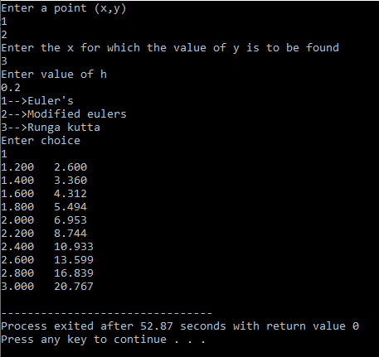

**Case 2(choose modified euler’s method):**

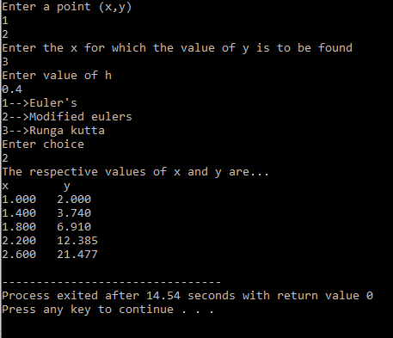

**Case 3(choose runga kutta method):**

